Using the TASMANIAN GOVERNMENT LOGO
to recognise SPONSORSHIP or SUPPORT

The Tasmanian Government provides specific logos (below) for use by organisations that need to recognise Government support or sponsorship.

It is important that these logos are used within the guidelines provided below. If you are unsure about recognising Tasmanian Government support, please refer to the requirements in your funding agreement, contact the department providing support to your organisation or email communications@dpac.tas.gov.au
MONO (black on a white background)
FULL-COLOUR
(on a white background)
REVERSED (white on a solid colour background)

Minimum width 20mm (2cm)

LOGO COLOUR
The logo may only appear in:
- full-colour – Blue PMS 653, Olive PMS 618 and Black
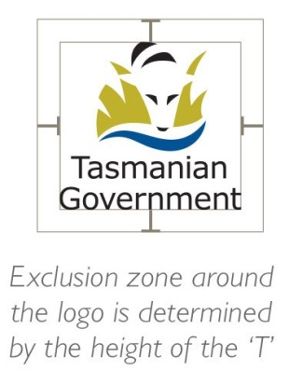
- black (mono)
- white (reversed out of a solid colour background).

MINIMUM SIZE AND CLEAR SPACE
The vertical logo must always be at least 20mm wide.
A certain amount of clear space must also be maintained around the logo. The exclusion zone (pictured right) shows the minimum space which must be left clear. This is measured by the ‘T’ in ‘Tasmania’ in the vertical logo.

PLEASE NOTE
- Do not change the format, colour, shape or typeface (font) used in the logo.
- Take care not to distort the logo when you are changing its size – its height and width must change in proportion so it is not squeezed or squashed.
- Do not create your own version of the logo or add any text; use only the versions supplied.

